|  |
| --- |
|  |
| National University of Computer & Emerging Sciences |
|  |

|  |  |
| --- | --- |
| Course Instructor | Sara Rehmat |
| Lab Instructor | Asad Khan |
| Semester | Fall 2020 |

Lab Manual

Introduction to Information & Communication Technologies



# Introduction to Microsoft Office Word 2007

**Objectives:**

Lab # 02: Introduction to Microsoft Office Word 2007

* Introduction to Microsoft Word
* Starting Word
* MS-Word 2007 vs. 2010
  + Screen Layout
  + Menus
  + The Microsoft Office Button
  + The Ribbon
  + Quick Access Toolbar
* Editing a Document
  + Typing and inserting Text
  + Selecting Text
  + Inserting Additional Text
  + Deleting Blocks of Text
  + Search and Replace Text
  + Undo Changes
  + Styles
  + Change Font Typeface and Size
  + Font Styles and Effects
  + Change Text Color
  + Highlight Text
  + Copy Formatting
  + Clear Formatting
* Formatting Paragraphs
  + Change Paragraph Alignment
* Align Left:  the text is aligned with your left margin
  + Indent Paragraphs
  + Add Borders and Shading
  + Apply Styles
  + Create Links
  + Change Spacing Between Paragraphs and Lines
* Adding Tables
  + Create a Table
  + Enter Data in a Table
  + Modify the Table Structure and Format a Table
* Graphics
  + Symbols and Special Characters
  + Equations
  + Illustrations, Pictures, and SmartArt
  + Watermarks
* Proofreading a Document
  + Spelling and Grammar
  + Thesaurus
  + Customize AutoCorrect
* Page Formatting
  + Modify Page Margins and Orientations
  + Apply a Page Border and Color
  + Insert Common Header and Footer Information
  + Create a Page Break
  + Insert a Cover Page
  + Insert a Blank Page
* Table of Contents
  + Mark Table of Contents Entries
  + Create a Table of Contents
  + Update Table of Contents
  + Delete Table of Contents
* Lists
  + Bulleted and Numbered Lists
  + Nested Lists
  + Formatting Lists

**Instructions:**

* You are allowed to use your own laptops.
* You can consult the books, manuals and class lectures.
* You should have stationary like register and ballpoint to analyze the tasks first.
* Ensure that you working environment is working properly.
* Only in practice session, consultation is allowed.
* Attempt all questions yourself.
* No discussion is allowed during tasks solution.
* Submission of all tasks’ solutions is necessary in any way.
* Tasks completed in specified time will be graded.
* Cheating is strictly prohibited otherwise rules as per university will be applied as a result of F-Grade in lab.
* This lab manual is prepared from <http://www.fgcu.edu/support/office2007/word/GettingStarted.asp>

**Getting Started**

## Introduction to Microsoft Word

Microsoft Office 2007 (officially called 2007 Microsoft Office System) is a Windows version of the Microsoft Office System, Microsoft's productivity suite. Microsoft Word 2010 is a word-processing program that can be used to create professional-looking documents such as reports, resumes, letters, memos, and newsletters. It includes many powerful tools that can be used to enhance the appearance of documents and collaborate with others. This handout provides an overview of the Word 2007 user interface and covers how to perform basic tasks such as creating, saving, editing, formatting, and printing documents, as well as getting help.

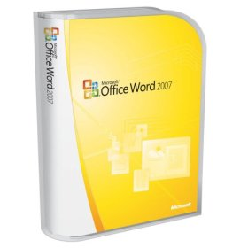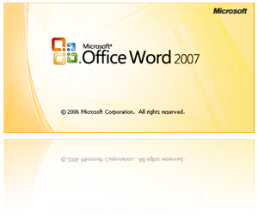

## Starting Word

There are multiple ways to start Word. You can start Word 2010 from the Start menu (in Windows 7) or by opening an existing Word file.

To start Word 2007 from the Start menu:

1. Click the **Start** button, click **All Programs**, click **Microsoft Office**, and then click **Microsoft Word 2007**. The program window opens with a new blank document.

## MS-Word 2007 vs. 2013

### Screen Layout



##### Word 2007 Program Window Elements

|  |  |
| --- | --- |
| **Name** | **Description** |
| Title bar | |  | | --- | | Appears at the top of the program window and displays the name of the | | Document and the program. The buttons on the right side of the Title bar are | | Used to minimize, maximize, restore, and close the program window. | |
| Quick Access toolbar | Appears on the left side of the Title bar and contains frequently used commands that are independent of the tab displayed on the Ribbon. |
| Ribbon | Extends across the top of the program window, directly below the Title bar, and consists of a set of tabs, each of which contains groups of related commands. |
| Navigation Pane | Appears on the left side of the program window and enables you to navigate long documents, search for specific text, and reorganize content. |
| Document Window | Appears below the Ribbon and displays the contents of the document |
| Cursor | Indicates where text or graphics will be inserted. |
| Scroll bar | |  | | --- | | Appear along the right side and bottom of the document window and enable | | You to scroll through the document. | |
| Status bar | Appears at the bottom of the program window and displays information about the document (number of pages, number of words, etc.). The tools on the right side of the Status bar can be used to display the document in a variety of views and to change the magnification of the document. |

### Menus

When you begin to explore Word 2007 you will notice a new look to the menu bar. There are three features that you should remember as you work within Word 2007: the Microsoft Office Button (now replaced with file button in Word 2013), the Quick Access Toolbar, and the Ribbon. These three features contain many of the functions that were in the menu of previous versions of Word. The functions of these three features will be more fully explored below.

### The Microsoft Office Button

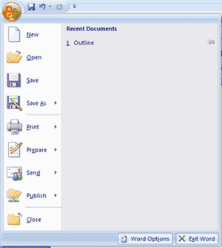

The Microsoft Office button performs many of the functions that were located in the File menu of older versions of Word. This button allows you to create a new document, open an existing document, save or save as, print, send (through email or fax), publish or close.

### The Ribbon

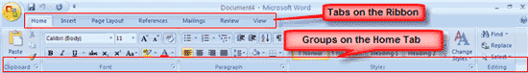

The Ribbon is the panel at the top portion of the document. It has seven tabs: Home, Insert, Page Layout, References, Mailings, Review, and View that contain many new and existing features of Word. Each tab is divided into groups. The groups are logical collections of features designed to perform functions that you will utilize in developing or editing your Word document. Commonly used features are displayed on the Ribbon, to view additional features within each group, click on the arrow at the bottom right of each group.

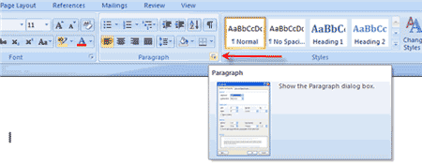

Each of the tabs contains the following tools:

**Home:** Clipboard, Fonts, Paragraph, Styles, and Editing.

**Insert:** Pages, Tables, Illustrations, Links, Header & Footer, Text, and Symbols

**Page Layout:** Themes, Page Setup, Page Background, Paragraph, Arrange

**References:** Table of Contents, Footnote, Citation & Bibliography, Captions, Index, and Table of Authorities

**Mailings:** Create, Start Mail Merge, Write & Insert Fields, Preview Results, Finish

**Review:** Proofing, Comments, Tracking, Changes, Compare, Protect

**View:** Document Views, Show/Hide, Zoom, Window, Macros

### Quick Access Toolbar

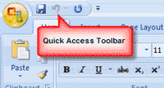

The quick access toolbar is a customizable toolbar that contains commands that you may want to use. You can place the quick access toolbar above or below the ribbon. To change the location of the quick access toolbar, click on the arrow at the end of the toolbar and click on Show below the Ribbon.

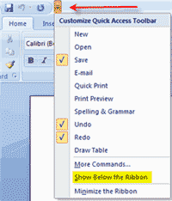

You can also add items to the quick access toolbar. Right click on any item in the Office Button or the Ribbon and click on Add to Quick Access Toolbar and a shortcut will be added to the Quick Access Toolbar.

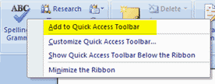

## Editing a Document

### Typing and inserting Text

To enter text, just start typing! The text will appear where the blinking cursor is located. Move the cursor by using the arrow buttons on the keyboard or positioning the mouse and clicking the left button. The keyboard shortcuts listed below are also helpful when moving through the text of a document:

|  |  |
| --- | --- |
| **Move Action** | **Keystroke** |
| Beginning of the line | **HOME** |
| End of the line | **END** |
| Top of the document | **CTRL+HOME** |
| End of the document | **CTRL+END** |

### Selecting Text

To change any attributes of text it must be highlighted first. Select the text by dragging the mouse over the desired text while keeping the left mouse button depressed, or hold down the **SHIFT** key on the keyboard while using the arrow buttons to highlight the text. The following table contains shortcuts for selecting a portion of the text:

|  |  |
| --- | --- |
| **Selection** | **Technique** |
| Whole word | double-click within the word |
| Whole paragraph | triple-click within the paragraph |
| Several words or lines | drag the mouse over the words, or hold down **SHIFT** while using the arrow keys |
| Entire document | choose **Editing | Select | Select All** from the Ribbon, or press **CTRL+A** |

Deselect the text by clicking anywhere outside of the selection on the page or press an arrow key on the keyboard.

Inserting Additional Text  
Text can be inserted in a document at any point using any of the following methods:

* **Type Text**:  Put your cursor where you want to add the text and begin typing
* **Copy and Paste Text**:  Highlight the text you wish to copy and right click and click **Copy**, put your cursor where you want the text in the document and right click and click **Paste**.
* **Cut and Paste Text**:  Highlight the text you wish to copy and right click and click **Cut**, put your cursor where you want the text in the document and right click and click **Paste**.
* **Drag Text**:  Highlight the text you wish to move, click on it and drag it to the place where you want the text in the document.

You will notice that you can also use the Clipboard group on the Ribbon.

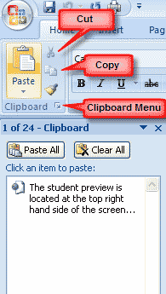

To rearrange text within a document, you can utilize the **Clipboard Group** on the **Home Tab** of the Ribbon.  
Insert picture of clipboard group labeled

* **Move text:**  Cut and Paste or Drag as shown above
* **Copy Text:**  Copy and Paste as above or use the Clipboard group on the Ribbon
* **Paste Text:**  Ctrl + V (hold down the CTRL and the “V” key at the same time) or use the Clipboard group to Paste, Paste Special, or Paste as Hyperlink

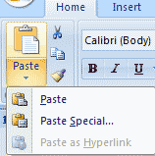

### Deleting Blocks of Text

Use the **BACKSPACE** and **DELETE** keys on the keyboard to delete text. Backspace will delete text to the left of the cursor and Delete will erase text to the right. To delete a large selection of text, highlight it using any of the methods outlined above and press the **DELETE** key.

### Search and Replace Text

To find a particular word or phrase in a document:

* Click **Find** on the **Editing Group** on the Ribbon
* To  find and replace a word or phrase in the document, click **Replace** on the **Editing Group** of the Ribbon

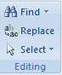

### Undo Changes

To undo changes:

* Click the **Undo Button** on the Quick Access Toolbar

Undo Button

### Styles

A style is a format enhancing tool that includes font typefaces, font size, effects (bold, italics, underline, etc.), colors and more. You will notice that on the Home Tab of the Ribbon, that you have several areas that will control the style of your document: Font, Paragraph, and Styles.

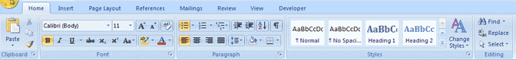

### Change Font Typeface and Size

**To change the font typeface:**

* Click the arrow next to the font name and choose a font.

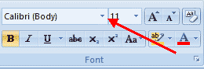

* Remember that you can preview how the new font will look by highlighting the text, and hovering over the new font typeface.

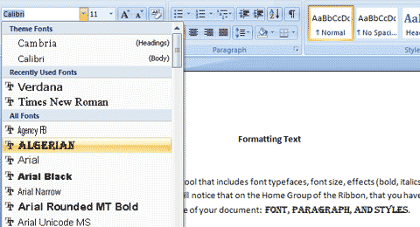

**To change the font size:**

* Click the arrow next to the font size and choose the appropriate size, or
* Click the increase or decrease font size buttons.

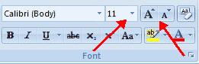

### Font Styles and Effects

Font styles are predefined formatting options that are used to emphasize text. They include: Bold, Italic, and Underline. To add these to text:

* Select the text and click the Font Styles included on the Font Group of the Ribbon, or
* Select the text and right click to display the font tools

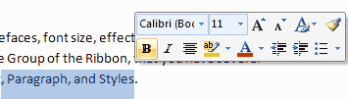

### Change Text Color

To change the text color:

* Select the text and click the **Colors** button included on the Font Group of the Ribbon, or
* Highlight the text and right click and choose the colors tool.
* Select the color by clicking the down arrow next to the font color button.

Font Color

### Highlight Text

Highlighting text allows you to use emphasize text as you would if you had a marker. To highlight text:

* Select the text
* Click the **Highlight** **Button** on the Font Group of the Ribbon, or
* Select the text and right click and select the highlight tool
* To change the color of the highlighter click on down arrow next to the highlight button.

### Copy Formatting

If you have already formatted text the way you want it and would like another portion of the document to have the same formatting, you can copy the formatting. To copy the formatting, do the following:

* Select the text with the formatting you want to copy.
* Copy the format of the text selected by clicking the **Format Painter** button on the Clipboard Group of the Home Tab
* Apply the copied format by selecting the text and clicking on it.

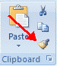

### Clear Formatting

To clear text formatting:

* Select the text you wish to clear the formatting
* Click the Styles dialogue box on the Styles Group on the Home Tab
* Click Clear All

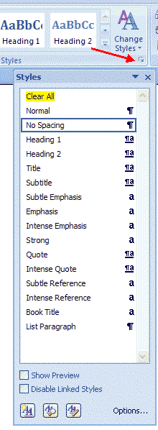

## Formatting Paragraphs

Formatting paragraphs allows you to change the look of the overall document. You can access many of the tools of paragraph formatting by clicking the Page Layout Tab of the Ribbon or the Paragraph Group on the Home Tab of the Ribbon.

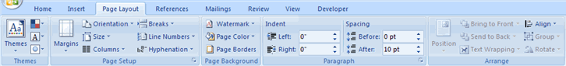

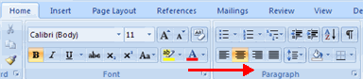

### Change Paragraph Alignment

The paragraph alignment allows you to set how you want text to appear.  To change the alignment:

* Click the **Home Tab**
* Choose the appropriate button for alignment on the Paragraph Group.

## Align Left:  the text is aligned with your left margin

* + **Center**:  The text is centered within your margins
  + **Align Right**:  Aligns text with the right margin
  + **Justify**:  Aligns text to both the left and right margins.

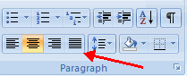

### Indent Paragraphs

Indenting paragraphs allows you set text within a paragraph at different margins. There are several options for indenting:

* **First Line**:  Controls the left boundary for the first line of a paragraph
* **Hanging**:  Controls the left boundary of every line in a paragraph except the first one
* **Left**:  Controls the left boundary for every line in a paragraph
* **Right**:  Controls the right boundary for every line in a paragraph

To indent paragraphs, you can do the following:

* Click the **Indent** buttons to control the indent.
* Click the **Indent** button repeated times to increase the size of the indent.

|  |
| --- |
|  |

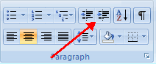

* Click the dialog box of the **Paragraph** Group
* Click the **Indents and Spacing** Tab
* Select  your indents

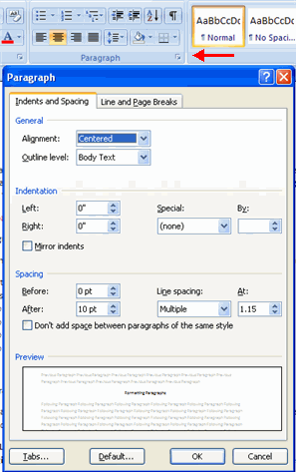

### Add Borders and Shading

You can add borders and shading to paragraphs and entire pages.  To create a border around a paragraph or paragraphs:

* Select the area of text where you want the border or shading.
* Click the **Borders** Button on the Paragraph Group on the Home Tab
* Choose the **Border and Shading**
* Choose the appropriate options

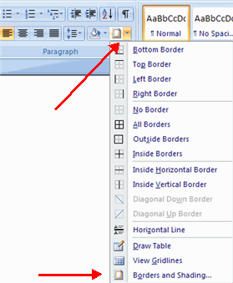

### Apply Styles

Styles are a present collection of formatting that you can apply to text. To utilize **Quick Styles:**

* Select the text you wish to format.
* Click the dialog box next to the **Styles Group** on the Home Tab.
* Click the style you wish to apply.

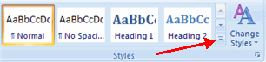

### Create Links

Creating links in a word document allows you to put in a URL that readers can click on to visit a web page.  To insert a link:

* Click the **Hyperlink Button** on the Links Group of the Insert Tab.
* Type in the text in the “Text to Display” box and the web address in the “Address” box.

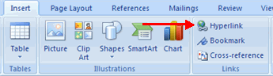

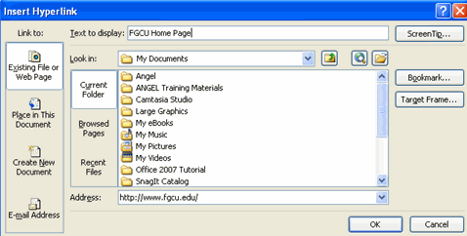

### Change Spacing Between Paragraphs and Lines

You can change the space between lines and paragraphs by doing the following:

* Select the paragraph or paragraphs you wish to change.
* On the Home Tab, Click the **Paragraph** Dialog Box
* Click the **Indents and Spacing** Tab
* In the **Spacing** section, adjust your spacing accordingly

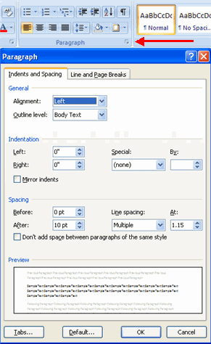

## Adding Tables

Tables are used to display data in a table format.

### Create a Table

To create a table:

* Place the cursor on the page where you want the new table
* Click the **Insert** Tab of the Ribbon
* Click the **Tables** Button on the Tables Group.  You can create a table one of four ways:
  + Highlight the number of row and columns
  + Click **Insert Table** and enter the number of rows and columns
  + Click the **Draw Table**, create your table by clicking and entering the rows and columns
  + Click **Quick Tables** and choose a table

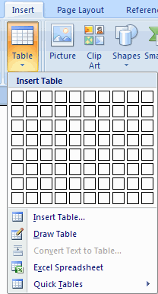

### Enter Data in a Table

Place the cursor in the cell where you wish to enter the information. Begin typing.

### Modify the Table Structure and Format a Table

To **modify** the structure of a table:

* Click the table and notice that you have two new tabs on the Ribbon:  **Design and Layout**.  These pertain to the table design and layout.

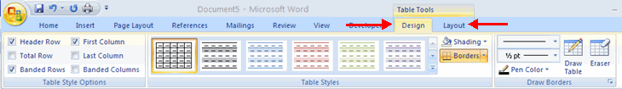

On the Design Tab, you can choose:

* **Table Style Options**
* **Table Styles**
* **Draw Borders**

To **format** a table, click the table and then click the **Layout** Tab on the Ribbon.  This Layout tab allows you to:

* **View Gridlines and Properties** (from the Table Group)
* **Insert Rows and Columns** (from the Rows & Columns Group)
* **Delete the Table, Rows and/or Columns** (from the Rows & Columns Group)
* **Merge or Split Cells** (from the Merge Group)
* **Increase and Decrease cell size** (Cell Size Group)
* **Align text within the cells and change text directions**(Alignment Group)

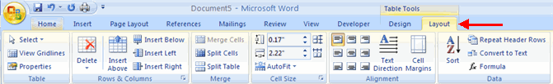

## Graphics

Word 2007 allows you to insert special characters, symbols, pictures, illustrations, and watermarks.

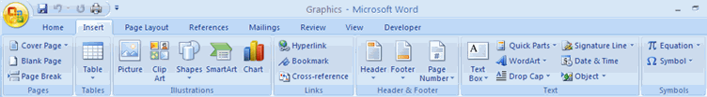

### Symbols and Special Characters

Special characters are punctuation, spacing, or typographical characters that are not generally available on the standard keyboard. To insert symbols and special characters:

* Place your cursor in the document where you want the symbol
* Click the **Insert** Tab on the Ribbon
* Click the **Symbol** button on the Symbols Group
* Choose the appropriate symbol.

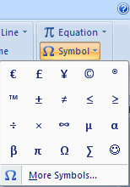

Equations  
Word 2007 also allows you to insert mathematical equations.  To access the mathematical equations tool:

* Place your cursor in the document where you want the symbol
* Click the **Insert** Tab on the Ribbon
* Click the **Equation** Button on the Symbols Group
* Choose the appropriate equation and structure or click Insert New Equation

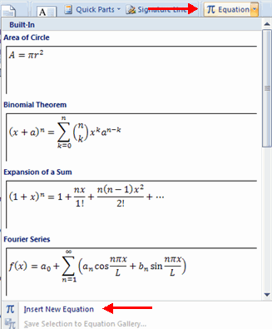

* To edit the equation click the equation and the **Design**Tab will be available in the Ribbon

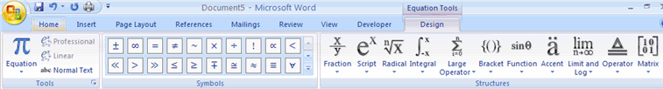

Illustrations, Pictures, and SmartArt

Word 2007 allows you to insert illustrations and pictures into a document.  To insert illustrations:

* Place your cursor in the document where you want the illustration/picture
* Click the **Insert** Tab on the Ribbon
* Click the **Clip Art** Button
* The dialog box will open on the screen and you can search for clip art.
* Choose the illustration you wish to include

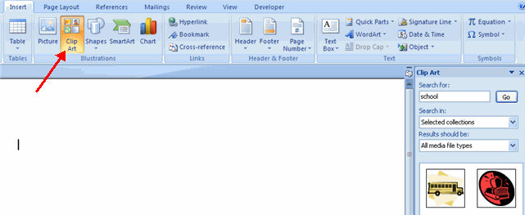

To insert a**picture**:

* Place your cursor in the document where you want the illustration/picture
* Click the **Insert** Tab on the Ribbon
* Click the **Picture** Button
* Browse to the picture you wish to include
* Click the **Picture**
* Click **Insert**

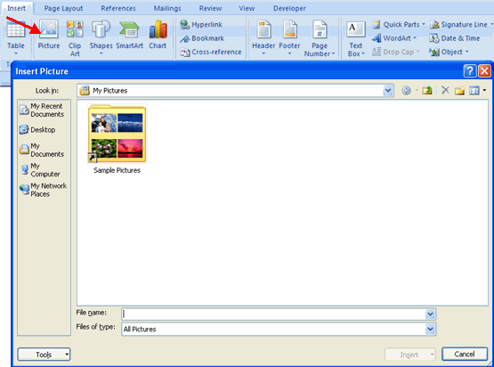

**Smart Art** is a collection of graphics you can utilize to organize information within your document.  It includes timelines, processes, or workflow. To insert SmartArt

* Place your cursor in the document where you want the illustration/picture
* Click the **Insert** Tab on the Ribbon
* Click the **SmartArt** button
* Click the **SmartArt** you wish to include in your document
* Click the arrow on the left side of the graphic to insert text or type the text in the graphic.

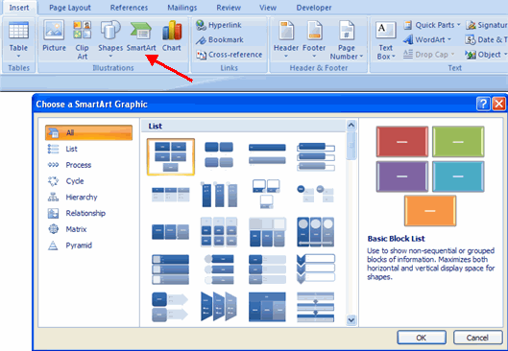

**Resize Graphics**  
All graphics can be resized by clicking the image and clicking one corner of the image and dragging the cursor to the size you want the picture.

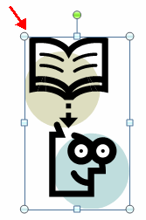

Watermarks  
A watermark is a translucent image that appears behind the primary text in a document.  To insert a watermark:

* Click the **Page Lay**out Tab in the Ribbon
* Click the **Watermark** Button in the Page Background Group
* Click the **Watermark** you want for the document or click **Custom Watermark** and create your own watermark
* To remove a watermark, follow the steps above, but click **Remove Watermark**

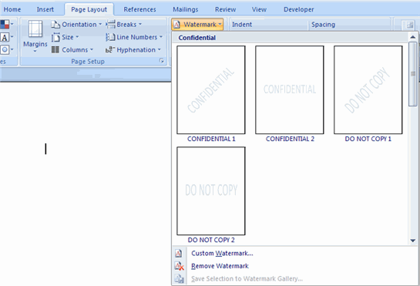

## Proofreading a Document

There are many features to help you proofread your document.  These include:  Spelling and Grammar, Thesaurus, AutoCorrect, Default Dictionary, and Word Count.

### Spelling and Grammar

To check the spelling and grammar of a document

* Place the cursor at the beginning of the document or the beginning of the section that you want to check
* Click the **Review** Tab on the Ribbon
* Click **Spelling & Grammar** on the Proofing Group.

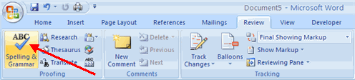

* Any errors will display a dialog box that allows you to choose a more appropriate spelling or phrasing.

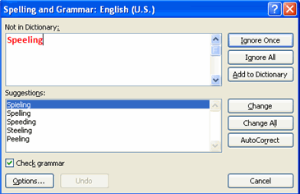

If you wish to check the spelling of an individual word, you can right click any word that has been underlined by Word and choose a substitution.

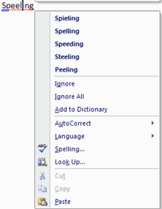

Thesaurus  
The Thesaurus allows you to view synonyms.  To use the thesaurus:

* Click the **Review** Tab of the Ribbon
* Click the **Thesaurus** Button on the Proofing Group.
* The thesaurus tool will appear on the right side of the screen and you can view word options.

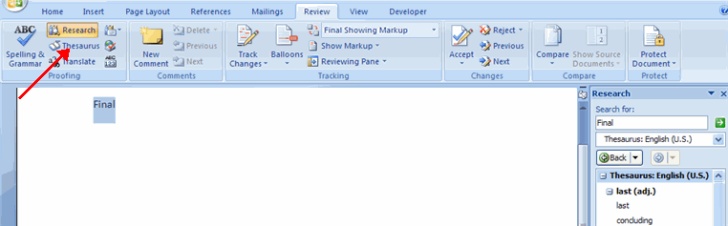

You can also access the thesaurus by right-clicking any word and choosing **Synonyms** on the menu.

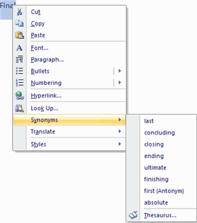

Customize AutoCorrect

You can set up the AutoCorrect tool in Word to retain certain text the way it is.  To customize AutoCorrect:

* Click the **Microsoft Office** button
* Click the **Word Options** Button
* Click the **Proofing** tab
* Click **AutoCorrect Options** button

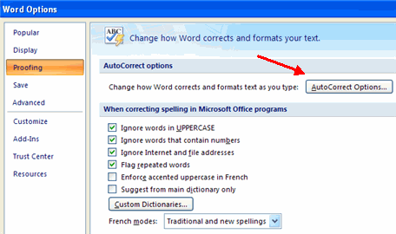

* On the **AutoCorrect Tab**, you can specify words you want to replace as you type

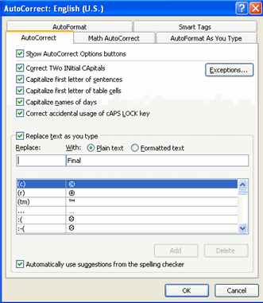

## Page Formatting

Modify Page Margins and Orientations

The page margins can be modified through the following steps:

* Click the **Page Layout** Tab on the Ribbon
* On the **Page Setup** Group, Click **Margins**
* Click a **Default Margin**, or
* Click **Custom Margins** and complete the dialog box.

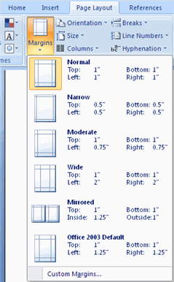

To change the Orientation, Size of the Page, or Columns:

* Click the **Page Layout** Tab on the Ribbon
* On the Page Setup Group, Click the **Orientation**, **Size**, or **Columns** drop down menus
* Click the appropriate choice

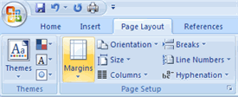

### Apply a Page Border and Color

To apply a page border or color:

* Click the **Page Layout** Tab on the Ribbon
* On the Page Background Group, click the **Page Colors** or **Page Borders** drop down menus

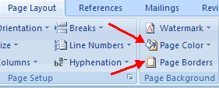

Insert Common Header and Footer Information  
To insert Header and Footer information such as page numbers, date, or title, first, decide if you want the information in the header (at the top of the page) or in the Footer (at the bottom of the page), then:

* Click the **Insert** Tab on the Ribbon
* Click **Header or Footer**
* Choose a style

I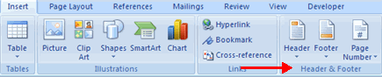

* The **Header/Footer Design** Tab will display on the Ribbon
* Choose the information that you would like to have in the header or footer (date, time, page numbers, etc.) or type in the information you would like to have in the header or footer

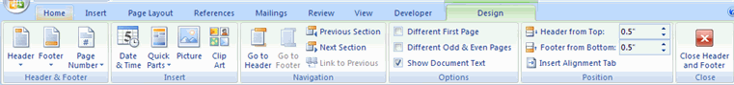

Create a Page Break

To insert a page break:

* Click the **Page Layout** Tab on the Ribbon
* On the **Page Setup**Group, click the **Breaks Drop Down Menu**
* Click **Page Break**

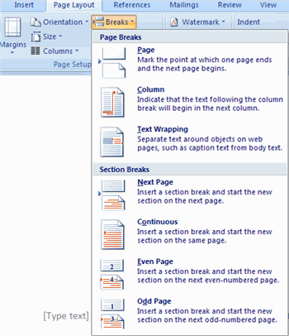

Insert a Cover Page

To insert a cover page:

* Click the **Insert** Tab on the Ribbon
* Click the **Cover Page** Button on the Pages Group
* Choose a style for the cover page

I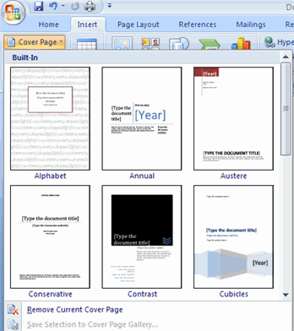

Insert a Blank Page  
To insert a blank page:

* Click the **Insert** Tab on the Ribbon
* Click the **Blank Page** Button on the Page Group

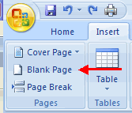

## Table of Contents

The easiest way to create a **Table of Contents** is to utilize the **Heading Styles** that you want to include in the Table of Contents.  For example:  Heading 1, Heading 2, etc. based on the content of your document.   When you add or delete headings from your document, Word updates your **Table of Contents**.  Word also updates the page number in the table of contents when information in the document is added or deleted. When you create a Table of Contents, the first thing you want to do is mark the entries in your document.  The Table of Contents is formatted based on levels of headings.  Level 1 will include any text identified with the style Heading 1.

Mark Table of Contents Entries  
you can mark the Table of Contents entries in one of two ways:  by using built-in heading styles or by marking individual text entries.

**To Use Built-In Heading Styles**

* Select the text that you wish to be the heading
* Click the **Home** Tab
* In the Styles Group, click **Heading 1** (or the appropriate heading)

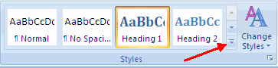

* If you don’t see the style you want, click the arrow to expand the **Quick Styles Gallery**
* If the style you want does not appear click **Save Selection** as New Quick Style

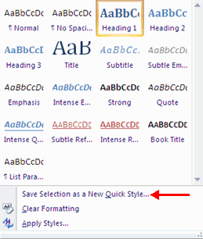

**To Mark Individual Entries:**

* Select the text you wish to make a heading
* Click the **References** Tab
* Click **Add Text**in the Table of Contents Group
* Click the **Level** that you want to label your selection

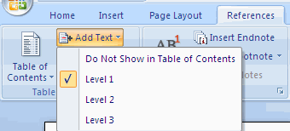

Create a Table of Contents  
To create the table of contents:

* Put your cursor in the document where you want the Table of Contents
* Click the **References** Tab
* Click the **Table of Contents** button

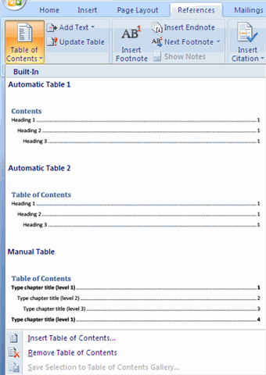

Update Table of Contents  
If you have added or removed headings or other table of contents entries you can update by:

* Apply headings or mark individual entries as directed above
* Click the **References** Tab in the Ribbon
* Click **Update Table**

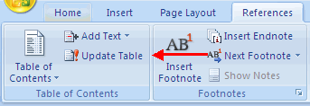

Delete Table of Contents  
To delete a table of contents:

* Click the **References** Tab on the Ribbon
* Click **Table of Contents**
* Click **Remove Table of Contents**

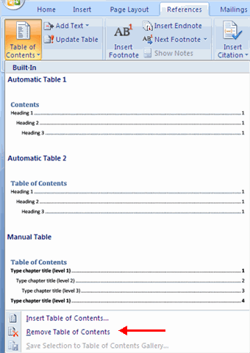

## Lists

Lists allow you to format and organize text with numbers, bullets, or in an outline.

Bulleted and Numbered Lists  
Bulleted lists have bullet points, numbered lists have numbers, and outline lists combine numbers and letters depending on the organization of the list.

To **add**a list to existing text:

* Select the text you wish to make a list
* From the Paragraph Group on the Home Tab, Click the **Bulleted or Numbered Lists** button

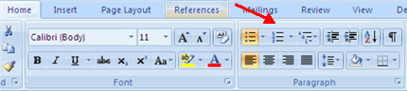

To **create** a new list:

* Place your cursor where you want the list in the document
* Click the **Bulleted or Numbered Lists** button
* Begin typing

Nested Lists

A nested list is list with several levels of indented text. To create a nested list:

* Create your list following the directions above
* Click the **Increase or Decrease Indent** button

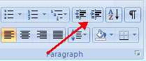

Formatting Lists

The bullet image and numbering format can be changed by using the **Bullets or Numbering** dialog box.

* Select the entire list to change all the bullets or numbers, or  
  Place the cursor on one line within the list to change a single bullet
* Right click
* Click the **arrow** next to the bulleted or numbered list and choose a bullet or numbering style.

